
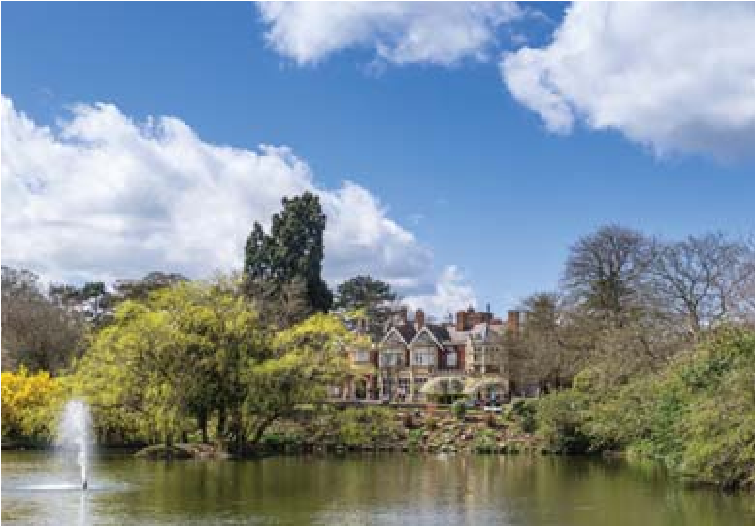



Price based on twin/double share. Minimum
numbers required. Normal booking conditions
Christ Church, Oxford
Oxford, Bletchley Park &
Blenheim Palace
The Arts Society Cavendish presents
Tailored Travel’s ATOL
number is 5605
days from £699
4
Departing 7th May 2027
View and share this tour online
- click on
View Your Tour
at www.tailored-travel.co.uk

and quote
cvsd271
Bletchley Park
For more information on this tour contact your Group Organiser
Sylvia McKenzie
Tel: 07970 277040
Email: sylviamck34@gmail.com
....................................................................
66
Chapel Road, Whaley Bridge,
High Peak SK23 7LB

• 4* hotel
• Half board accommodation
• All excursion travel &
guided tours included
• Entrance fees to non-National Trust
properties included
• Blue Badge guide included on Day 3
• Executive coach throughout

• Baddesley Clinton
• Bletchley Park – guided tour
• Oxford – guided walking tour
• Ashmolean Museum – guided tour
• Blenheim Palace – guided tour

We stay three nights at the 4* Oxford
Belfry Hotel, on the outskirts of Oxford
www.theoxfordbelfry.co.uk). Located
(
in a countryside setting, thirteen miles
from the famous university city of
Oxford, facilities at the hotel include a
restaurant, bar, indoor swimming pool,
sauna, steam room and gymnasium.
All rooms are en suite and feature
television, telephone, hair dryer and tea
& coffee making facilities. A set 3
course dinner without drinks is
included in our hotel on the first night.
A choice 3 course dinner without
drinks is included in our hotel on the
remaining two nights of our tour.
.

• Insurance (including Covid cover) £38
• Single room supplement £99
• Entrance fee to Baddesley Clinton
free to National Trust members)
(
• Gratuities
• Lunches
EXTRAS TO YOUR TOUR
ACCOMMODATION
WHAT WE WILL SEE
FEATURES

WHAT WE WILL SEE
Baddesley Clinton
Bletchley Park
Guided walking tour of Oxford
Ashmolean Museum
Blenheim Palace
Baddesley Clinton
Oxford
Ashmolean Museum
Blenheim Palace
The Arts Society Cavendish presents
Oxford, Bletchley Park & Blenheim Palace
4 days from £699 Departing 7th May 2027
Day 1
We depart by executive coach from our designated pick up points. En route to our hotel we visit the National Trust’s Baddesley Clinton property in Warwickshire, a romantic and atmospheric moated manor house, dating from the 15th century and little changed since 1634. The interiors reflect the house’s heyday in the Elizabethan era, when it was a haven for persecuted Catholics. The peaceful gardens include fish pools and a walled garden. We continue to the 4* Oxford Belfry Hotel, on the outskirts of Oxford for a three night stay on a half board basis.
Day 2
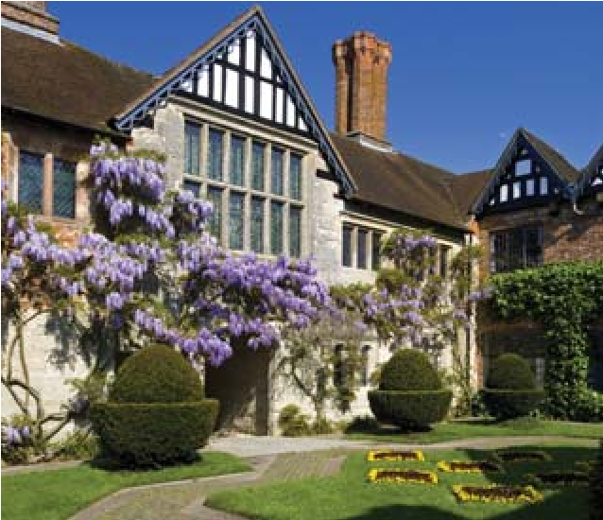
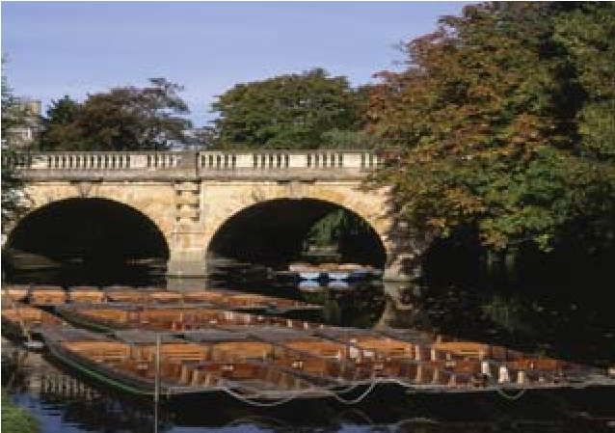
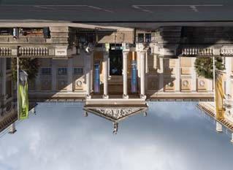



Today we enjoy a guided tour at Bletchley Park near Milton Keynes, the historic site of secret codebreaking activities during World War II and birthplace of the modern computer. Bletchley Park is home to the most comprehensive public display of Enigma machines in the world, including the rare 'Abwehr G312', a captured German machine used to encode messages. Other exhibitions include Hitler's "Unbreakable" Cipher Machine, the world's only fully operational Bombe rebuild, The Life and Works of Alan Turing Gallery and a Home Front exhibition, as well as an outstanding Churchill collection and numerous artefacts and documents which tell tales of spies and strategic deception.
Day 3
Our Blue Badge guide meets us at our hotel this morning and accompanies us throughout the day. Our morning guided tour of Oxford, the City of Dreaming Spires, takes in the architecture and traditions of the city’s most famous buildings and institutions. After some free time at leisure for lunch, we visit the Ashmolean Museum with our Blue Badge guide for a guided tour. Founded in 1683, the
Ashmolean is Britain’s first public museum and home to the
University of Oxford’s world class collection of art and archaeology.
Day 4
After checking out of our hotel visit Blenheim Palace for a guided tour, home of the 12th Duke of Marlborough and birth place of Sir Winston Churchill. The imposing scale of the Palace is beautifully balanced within by the intricate detail and delicacy of the carvings, the hand painted ceilings and the amazing porcelain collections, tapestries and paintings displayed in each room. Set in beautiful parkland of 2100 acres, which was landscaped by ‘Capability’ Brown in the 1760’s, the Palace is surrounded by sweeping lawns and formal gardens. Taking carefully selected comfort stops en route, we return back to our original pick up points.
NB:- Please note we reserve the right to alter the above itinerary if required for operational reasons. Given the historic nature of the places visited, a certain degree of walking will be involved, and this tour may not be suitable for those with mobility problems.

View and share this tour online - click on View Your Tour at www.tailored-travel.co.uk and quote cvsd271
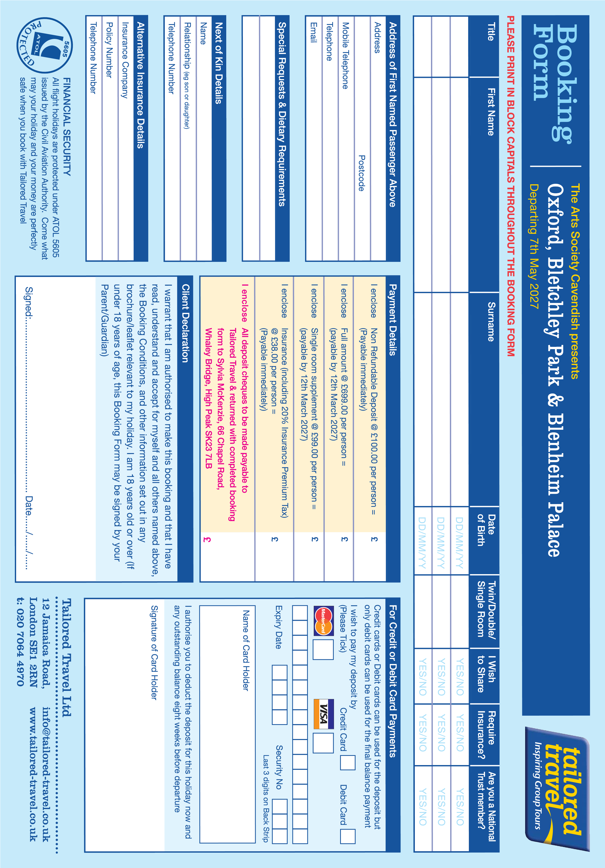



BOOKING CONDITIONS
It is important that you read the following conditions together with additional general information contained within the brochure for your holiday. In these Booking Conditions, “we”, “us” and “our” are Tailored Travel Limited.

1. HOLIDAY PAYMENT
When you book you must pay the appropriate deposit per person together with any applicable insurance premiums. The balance of the price of the holiday is due for payment 8 weeks (unless otherwise stated) before the departure date. If the balance is not paid in time we reserve the right to treat your booking as cancelled by you and apply the cancellation charges set out in clause 3 below. For bookings made within 8 weeks of departure the full amount is due at the time of booking. If you book a holiday which does not include flights through one of our authorised travel agents all monies you pay to him for that holiday will be held on your behalf until a contract between us comes into existence. After that point all such monies will be held on our behalf. If you book an air holiday with us through one of our authorised travel agents, any monies you pay to your travel agent for that holiday will be held on our behalf until they are paid to us or refunded to you.

2. CONFIRMATION OF BOOKING
These booking conditions form the basis of your contract with us. Your contract comes into existence when we despatch our confirmation invoice and will be governed by English law and subject to the exclusive jurisdiction of the Courts of England and Wales. We expect to confirm your booking within 10 days of receiving your booking form and deposit or full payment as applicable. You must check your confirmation invoice, tickets and all other documents you receive from us carefully as soon as you receive them. Please contact us immediately if any information on any document appears to be incorrect as it may not be possible to make changes later. We regret we cannot accept any liability if we are not notified of any inaccuracy in any document within 5 days of our sending it out.

3. HOLIDAY CANCELLATION BY YOU
If you have to cancel your holiday you must do so in writing. The cancellation charges you incur depend on when we receive this written notification and are as follows:
Receipt of notice | Cancellation Fee (Per Person)
More than 56 days before departure | Loss of deposit
Between 29 and 56 days | 50% or full
before departure | deposit if greater
Between 8 and 28 days | 75% or full
before departure | deposit if greater
7 days before departure or less | 100%
In the event of a cancellation of a booking secured by a low deposit, we reserve the right to levy the full deposit amount.
Percentages refer to the total holiday price excluding any amendment charges and insurance premiums which are non-refundable.
If a room or cabin is booked for multiple occupancy, but, due to cancellation by one or more of the occupants before departure, it becomes occupied by a single passenger then a charge equivalent to any sole occupancy fee charged by our suppliers will be added to the above cancellation charges.

4. HOLIDAY ALTERATION BY YOU
Should you wish to make any changes to your holiday, please advise us as soon as possible in writing. We will endeavour to meet requests if we can. A change of holiday where you wish to travel earlier or later than originally booked, will be treated as a cancellation of the original booking and charges will be levied according to clause 3. NB Insurance premiums are not transferable from one person to another.

5. ALTERATIONS AND CANCELLATIONS BY US
Occasionally, we have to make changes to and correct errors in the brochure or booklets supplied and other details both before and after bookings have been confirmed and cancel confirmed bookings. Whilst we always endeavour to avoid changes and cancellations, we must reserve the right to do so. Most changes are minor. Minor changes do not entitle you to cancel or change to another holiday without paying our normal charges. A change in the airline, aircraft type and airport of departure or destination previously provided at any time will be treated as a minor change. Occasionally, we have to make a significant change to your holiday. When we refer to a "significant change" in these Booking Conditions, we mean a change of outward departure time of more than 12 hours, a change of departure point to one which is significantly more inconvenient for you, a change of country of destination, a change of accommodation to that of a lower category for the whole or the majority of your holiday. If we have to make a significant change or cancel, we will tell you as soon as possible. Subject to clauses 6 and 12 below, if there is time to do so before departure you will then be given the choice of accepting the changed arrangements or taking a suitable alternative holiday with us if available or receiving a refund of monies paid to us. Should the alternative holiday be more expensive than the original one, there will be no further cost to yourself. Should the alternative holiday be less expensive than the original one, we will refund the difference.
Please note, our liability for significant changes and cancellations is limited to offering you the above mentioned choices. Where our liability is limited, we regret we cannot pay any expenses, costs or losses you may incur as a result of any change or cancellation. No compensation is payable for minor changes or where we cancel or make a significant change before the date the balance of your holiday cost falls due.

6. FORCE MAJEURE
We cannot accept liability or pay any compensation where the performance or prompt performance of our contractual obligations is prevented or affected by any event or circumstances beyond our control. Such events may include (but are not limited to) war or threat of war, riot, civil strife, terrorist activity, adverse weather conditions, natural or nuclear disaster, industrial dispute, government action, fire, pandemic/epidemic and similar events or circumstances outside our control. Where any such events lead to the cancellation of your holiday, we will refund monies paid to us (less any insurance premium and a contribution to any unrecovered costs up to a maximum of £75 per person).

7. PRICING POLICY
For flight tours and for tours to countries other than the UK, the price of your tour is calculated using the currency exchange rate at the time the tour was initially costed and a reasonable estimate of the projected transport costs at the date of departure. In limited circumstances the price of your confirmed holiday is subject to a surcharge as set out below. Surcharges can arise if there is an increase in tax, levy or other sum imposed by any government or regulatory authority/body (eg CAA, ATOL etc) or if our costs increase as a result of currency exchange rate fluctuation or if transport costs are in excess of our estimate. In the unlikely event that your holiday is surcharged you will be notified in writing not less than 30 days before departure. In any event we will absorb increases up to a total amount equivalent to 2% of the total holiday price which excludes insurance premiums and any amendment/cancellation charges. Only amounts in excess of this 2% will be surcharged. If this means paying more than 8% of the holiday price, excluding insurance premiums and any amendment charges, you will be entitled to cancel your holiday with a full refund of all money paid to us except for any premium paid to us for insurance and any amendment/cancellation charges already incurred. You will have 14 days to exercise your right to cancel from the issue date of the surcharge invoice. Should any surcharges be applied and shown on a final invoice any further increases would be borne by us. If there is a decrease in such costs of more than 2% of the holiday price, excluding insurance premiums and any amendment charges, then on your request in writing received by us not less than 30 days before departure you will be entitled to a price reduction corresponding to such decrease. We reserve the right to correct errors in both advertised and confirmed prices at any time. We will do so as soon as we become aware of the error.

8. PERSONAL LUGGAGE
Whilst every effort will be made by our contractors to ensure your luggage is kept safe throughout the duration of your holiday, customers are respectfully reminded that the ultimate responsibility for all personal luggage remains that of the individual customer.

9. LOSS OF PERSONAL PROPERTY
If your baggage is lost whist flying, a Property Irregularity Report should be completed at the airport prior to exiting the airport’s baggage area. For those who have taken out the holiday insurance we offer, the holiday insurance company insists that you report any loss or theft to the local police within 24 hours. Keep a note of where you reported the loss or theft and obtain a written report from the local police, this will assist when your insurance company asks for evidence of loss or theft. On your return home contact the holiday insurance company for a claims form (See also clause 18). If you have not taken out the insurance we offer, please check your policy.

10. SPECIAL REQUESTS
Although we will endeavour to pass any reasonable requests on to the relevant supplier, we regret we cannot promise that any request will be complied with unless we have specifically confirmed this in writing. Confirmation that a special request has been noted or passed on to the supplier or the inclusion of the special request on your confirmation or any other document is not confirmation that the request will be met. Unless and until specifically confirmed, all special requests are subject to availability.

11. OUR BROCHURE DESCRIPTIONS
All descriptions of holidays are advertised by us in good faith and we take care over accuracy. As our brochures are produced many months in advance of your departure, there may be times when an advertised facility, excursion or entertainment is not available during your particular holiday. Travel arrangements are planned very carefully to give you the maximum value while operating under normal circumstances. It may be necessary, sometimes at short notice, to make changes to an itinerary. Such reasons as weather, traffic and road conditions can create changes to an itinerary. Regrettably coaches, trains, ships and aircraft do occasionally break down or certain facilities on board a coach, train , ship or aircraft may become faulty. Every effort will be made to repair breakdowns or faults as quickly as possible. In some instances it may be necessary to replace the vehicle or aircraft which cannot be repaired. We cannot accept any responsibility for delays caused by any form of breakdown. During your stay in a hotel you may have problems with certain aspects of maintenance, generally caused by wear and tear to such items as a shower unit, lock etc. Please be understanding of such matters and report them to the hotel reception in a firm but polite manner. Hot water supplies can be occasionally limited in hotels and we cannot exercise any control over this. You may find that bed linen is not as large as you have at home, and towels which may not always be supplied, can be rather small. Regrettably, the general standards of safety, hygiene, fire precautions etc. vary from country to country and can in some instances be lower than you are used to in the U.K. The monitoring and enforcement of such matters is governed by the authorities of the country and overseas supplier of the services concerned. Please note, the services which make up your holiday comply with the standards and requirements of the country in which those services are provided and not those of the U.K.

12. ARTISTS, CONCERTS, ENTERTAINMENTS AND RIDES
We cannot accept responsibility for the non-appearance of any artist or the cancellation / withdrawal / closure of any concert / event / entertainment / ride (e.g. at Oberammergau Passion Play) for whatever reason. Should any such situation arise the holiday arrangements will still proceed. We will not always be in a position to advise you in advance of any such cancellation etc. Such situations will not constitute a significant change to your holiday arrangements entitling you to cancel or change to another holiday without paying our normal charges and no compensation will be payable.

13. SUPPLIERS
Whenever you use the services provided by an independent supplier you will be subject to the conditions of that supplier. These conditions form part of the agreement between us and may limit or exclude the liability of the supplier and us to you, often in accordance with international conventions. Copies of these conditions and the International Conventions are available from our office on request and can be inspected at the office of the suppliers concerned. We regret we cannot exercise any control over industrial disputes, port disputes or any similar action outside our control.

14. TRAVEL DELAY
Due to circumstances completely beyond our control, a delay may arise to your sea crossing/tunnel crossing/rail/air departure. In the event of any delay to your rail/air departure, responsibility for any meals etc. rests with the ferry company, airline or rail operator. In the event of extended overnight delays, depending on circumstances, we will endeavour to provide hotel accommodation.

15. HEALTH REGULATIONS
We advise you to check with your Doctor or the Department of Health in good time before travelling whether vaccinations are required for any of our holidays. Information on your health abroad is available from your local main Post Office.

16. HOLIDAY INSURANCE
- It is compulsory that you have comprehensive holiday insurance before travel. Should you decide on an alternative policy to the travel insurance policy offered in the brochure, you must give us the name, address, policy number and details of the emergency medical and repatriation telephone number relating to the alternative arrangements either at the time of booking or within 14 days of you taking out your alternative travel insurance policy. If you do not take out any holiday insurance or do not provide the required details in time, we reserve the right to refuse your booking and/or treat your booking as cancelled by you and apply the cancellation charges as set out in clause 3. Your holiday insurance must have no less cover than that available in the travel insurance policy offered by us in the brochure. It is your responsibility to ensure that the insurance cover you purchase is adequate for your particular needs.
- The travel insurance policy offered in the brochure will suit the Demands and Needs of an individual, or group (where applicable) who have no excluded pre-existing medical conditions and who wish to insure themselves against the financial impact of specified unforeseen circumstances/events relating to or occurring during the trip. Full details of these circumstances/events, levels of cover and terms and conditions can be found in the policy booklet.
IMPORTANT – you may already possess alternative insurance(s) for some or all of the features and benefits provided by this product; it is your responsibility to investigate this. We will not provide you with advice about the suitability of this product for your individual needs; we will however be happy to provide you with factual information to aid you in making your own informed buying decision. Tailored Travel Limited is an Appointed Representative of Wrightsure Services
(Hampshire) Limited who are authorised and regulated by the Financial Conduct Authority (their registration number is 311394) and which is permitted to advise on and arrange general insurance contracts. You can check these details online using the Financial Services Register
(accessible from www.fca.org.uk) or by contacting the FCA Consumer Helpline on 0800 111 6768.

17. COMPLAINTS PROCEDURE
Should you have a complaint about any aspect of your holiday, you must notify the tour manager, coach driver or a representative of the company, together with the supplier of the services in question immediately so that the problem can be quickly resolved on the spot. If the matter cannot be put right on the spot, on your return from holiday, you must write to us within 28 days with full details. For all complaints and claims which do not involve personal injury, illness or death, we regret we cannot accept any liability if you fail to notify the complaint or claim entirely in accordance with this clause.

18. OUR LIABILITY

(EVENTS CONNECTED WITH YOUR HOLIDAY PACKAGE)
- We accept responsibility for ensuring that your holiday is supplied to you as described in the brochure and to a reasonable standard. We also accept responsibility for what our employees, agents, suppliers and subcontractors do or do not do (providing they were at the time carrying out work authorised by us) except where death, personal injury or illness results (dealt with separately below).This acceptance of responsibility is, however, subject to clauses 6 & 12 and the other terms of these Booking Conditions.
- Subject to these Booking Conditions, we accept responsibility should you or any member of your party suffer death, personal injury or illness as a result of any failure to perform or improper performance of any part of our contract with you by any of our employees, agents, suppliers or subcontractors (providing they were at the time carrying out work authorised by us) except in the following situations. We will not be liable where any failure to perform or improper performance of the whole or any part of our contract was due to:
- the act(s) and/or omission(s) of the person(s) affected or
- those of a third party not connected with the provision of your holiday and which were unforeseeable or unavoidable or
- an event which either ourselves or the supplier of the service(s) in question could not have foreseen or avoided even with all due care.
- We limit the maximum amount we may have to pay you for any and all claims or parts of claims which do not involve personal injury, illness or death. Except where loss and/or damage to or of luggage or personal possessions is concerned or a lower limitation of liability applies to the claim, the maximum amount we will have to pay you for such non-personal injury claims if we are found liable to you on any basis is twice the price (excluding insurance premiums and amendment charges) paid by or on behalf of the person(s) affected in total.
- Where we are found liable for loss of and/or damage to any luggage or personal possessions (including money), the maximum amount we will have to pay you is £60 per person affected as you are assumed to have taken out travel insurance which is adequate or your requirements.
- It is a condition of the acceptance of liability set out in clauses 18(1) and 18(2) of these Booking Conditions that you notify us of any claim you or any member(s) of your party has in accordance with the procedure set out in clause 17,“COMPLAINTS PROCEDURE”. Any person to whom any payment is made must also assign to ourselves or our insurers any rights they may have to pursue any third party in connection with the claim. You must also provide ourselves and our insurers with all assistance we may reasonably require.
- Except where otherwise expressly stated in these booking conditions, where any claim or part of a claim concerns or is based on any travel arrangements (including the process of getting on or off the transport concerned) provided by any carrier or any stay in a hotel, the maximum we will have to pay you in respect of that claim or part of a claim if we are found liable to you on any basis is the maximum which would be payable by the carrier or hotel keeper concerned under the applicable international conventions (e.g. Warsaw convention as amended for international travel by air and/or for carriers with an operating licence granted by an E.U. country, the E.U. Regulation on air carrier liability for any travel by air) in that situation.
- Please note, we cannot accept any liability for any damage, loss, expense or other sum(s) of any description which (a) on the basis of the information given to us by you concerning your booking prior to our accepting it, we could not have foreseen you would suffer or incur if we breached our contract with you or (b) did not result from any breach of contract or any other fault by ourselves or our employees or, where we are responsible for them, our suppliers.
Additionally, we cannot accept liability for any business losses.

19. PASSENGERS WITH A DISABILITY
Please note, our holidays may not be suitable for people with certain disabilities or medical conditions. If you have a disability, coaches can be difficult to get on and off and some of our hotels do not offer ground/lower floor accommodation or lifts/easy access. Should any member of your party suffer from any disability or medical condition which may affect their or other people's holidays you must provide full written details at the time you book the holiday including any specific requirements that person has. Additionally at the time you book the holiday you must provide written confirmation that all assistance the person concerned requires will be provided by other party members as outside assistance will not be available. In view of the nature of our holidays, we regret we must reserve the right to decline any booking whenever we feel unable to accommodate the needs of any particular client or where, in our opinion, the medical condition or disability of the client concerned is likely to have a significant adverse effect on other clients taking the same holiday. We further reserve the right to cancel any holiday and impose cancellation charges if we are not fully advised of any relevant disability or medical condition at the time the booking is made. This does not affect your statutory rights.

20. INDEMNITY
If your actions or those of any member of your party cause damage to the accommodation in which you are staying or to the vehicle, train, ship or aircraft in which you are travelling, or cause delay or diversion to any means of transportation, you agree to fully indemnify us against any claim (including legal costs of all concerned) made against us by or on behalf of the owners of such accommodation or the operator of such means of transportation or by any third party.

21. INFORMATION REFERRING TO OUR TOURS
We always endeavour to give precise, accurate information to telephone enquiries. However, we cannot accept liability for information given orally to customers unless it is confirmed by us in writing.

22. PASSPORTS, VISAS. ETC.
It is your responsibility to ensure that you and those for whom you are booking are in possession of valid passports and any appropriate visas and are able to comply with any entry requirements of countries being travelled through. Be sure to check passport, visa and entry requirements with the consulates of countries being travelled through well in advance. You are responsible for any charges, fines etc, that may be levied by authorities in the UK or overseas for non compliance with regulations in the area and any such amounts will be recharged to you. You will not be permitted to travel overseas without an appropriate passport and all applicable visas. UK passports should be less than 10 years old and valid for at least 6 months beyond your planned date of return to the UK.

23. PERSONAL DETAILS
We may have to pass on certain details to a company or organisation (for example, the airline, hotel or credit card company) in order that your holiday or other service or product can be provided. We may be required to provide information by law as permitted by relevant data protection legislation or by a legal authority. When you make a booking or enter into a transaction this means you consent to our passing on such details in all such circumstances. We will also use the information you provide to send you details about our products and services now and in the future. We may also pass your details to third parties working on our behalf. If you do not want us to do this you must write to the Data Controller‚ at our head office address. We will not sell or pass your details to any individual or company which is not a subsidiary or parent of ours without your prior consent except in the circumstances shown above. You are entitled to see a copy of all the data we hold relating to you personally.

24. CONSISTENCY
In the event of any inconsistency between these Terms and Conditions and the additional general information in the brochure, these Terms and Conditions will apply in respect of the inconsistency.

25. YOUR FINANCIAL PROTECTION
- The air holidays and flights in the brochure are ATOL protected, since we hold an Air Travel Organiser's Licence granted by the Civil Aviation Authority. Our ATOL number is ATOL 5605. In the unlikely event of our insolvency, the CAA will ensure that you are not stranded abroad and will arrange to refund any money you have paid for an advance booking. For further information, visit the ATOL website at www.atol.org.uk.
- When you buy an ATOL protected flight inclusive holiday from us you will receive an ATOL Certificate. This lists what is financially protected, where you can get information on what this means for you and who to contact if things go wrong. We will provide you with the services listed on the ATOL Certificate. In some cases, where we are unable to do so for reasons of insolvency, an alternative ATOL holder may provide you with the services you have bought or a suitable alternative (at no extra cost to you). You agree to accept that in those circumstances the alternative ATOL holder will perform those obligations and you agree to pay any money outstanding to be paid by you under your contract to that alternative ATOL holder. However, you also agree that in some cases it will not be possible to appoint an alternative ATOL holder, in which case you will be entitled to make a claim under the ATOL scheme (or your credit card issuer where applicable).
- If we are unable to provide the services listed in your ATOL Certificate (or a suitable alternative, through an alternative ATOL holder or otherwise) for reasons of insolvency, the Trustees of the Air Travel Trust may make a payment to (or confer a benefit on) you under the ATOL scheme. You agree that in return for such a payment or benefit you assign absolutely to those Trustees any claims which you have or may have arising out of or relating to the non-provision of the services, including any claim against us, the travel agent (or your credit card issuer where applicable). You also agree that any such claims may be re-assigned to another body, if that other body has paid sums you have claimed under the ATOL scheme.
- Your non ATOL financial protection is covered by a separate trust account administered by independent chartered accountants.

Ref: Tailored Travel 05.11.20

