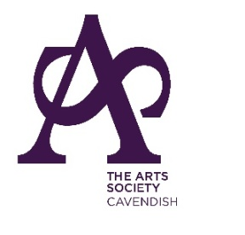

(Member Society of The Arts Society)

July 2020
Dear Member

We would like to thank you for your support through another strange year and hope that you enjoyed those lectures and study days which took place on Zoom. We have planned another great programme for the forthcoming year. We do hope that you will renew your membership and continue your support of the Society.
In order to do so please complete (in block letters) and return this form together with your cheque (no staples please), no later than 1st July 2021 to:

Mrs Joan E Knox, 33 Temple Road, Buxton, SK17 9BA

I/we do/do not wish to renew my/our membership £38 per member
(delete as appropriate)

Cheques should be made payable to The Arts Society Cavendish.
(receipts are not issued)

Name(s)______________________________________________________

Address:_________________________________________________________________________

______________________________________________________ Postcode:__________________

E-mail:____________________________________________

Tel:___________________________________ Mobile ____________________________________

The newsletter will be e-mailed to you in September and your programme booklet will be posted to you before the September meeting. In the meantime please look at our website www.artsocavendish.co.uk where you will find newsletters, programmes and lots more.

If you do not intend to renew membership we would appreciate it if you would let us know why:
(please tick any that apply)
◻ Moving away ◻ No longer able to actively participate ◻ Time pressures
◻ Too expensive ◻ Other (please specify)
________________________________________________________________________________

The Arts Society Cavendish is always looking for volunteers to help with the running of the Society. Please tick here □ if you would be willing to help.

GDPR Compliance:
Your details will be kept safely and securely and you have the ability to opt out of our communications at any time
Members’ details will be processed fairly and lawfully in order to satisfy the agreement entered with you on your admittance to membership. This will ensure that you receive the latest news and information about all upcoming events. Members’ details will be passed to “The Arts Society” to enable inclusion on the mailing of the quarterly magazine and other communications including information about any upcoming national events or items of legitimate interest. Members’ details may be passed to “The Arts Society Area”, or other affiliated societies for the purposes of disseminating relevant information of legitimate interest

